

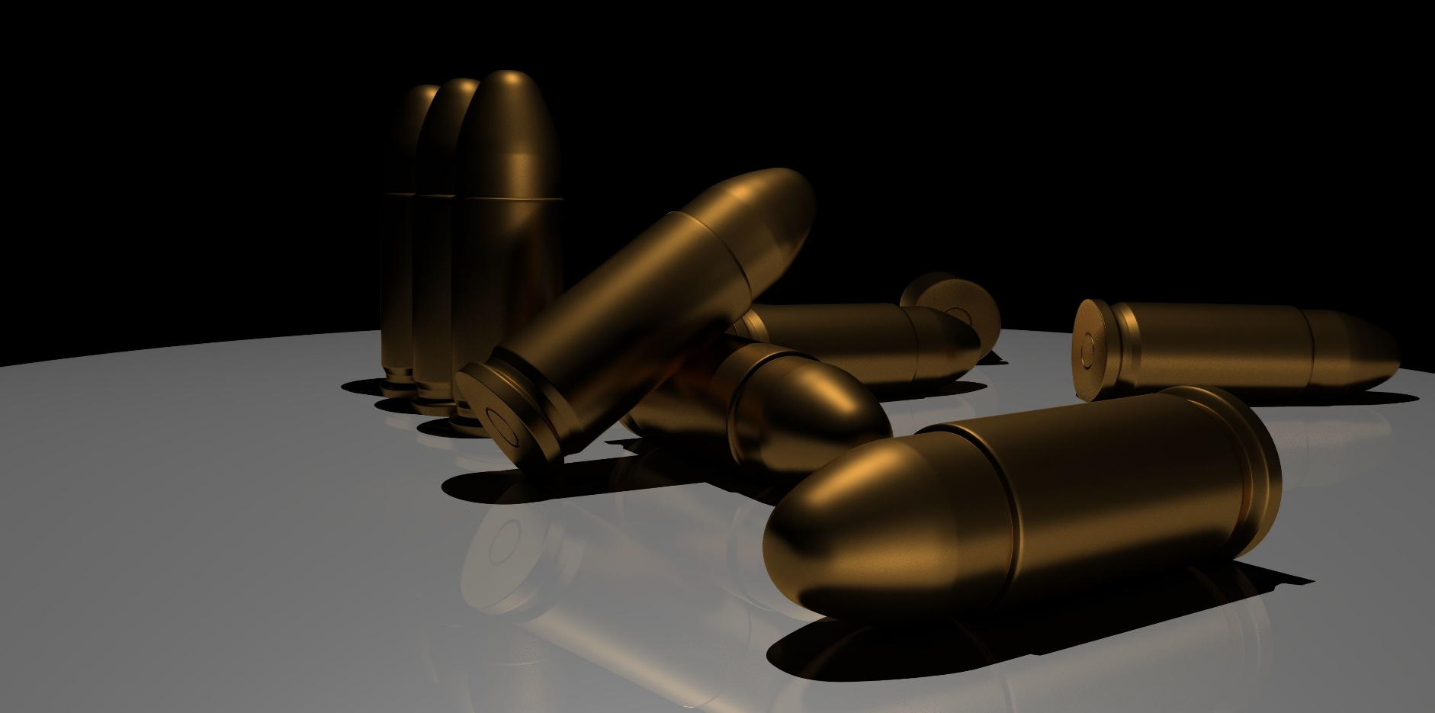

***yippi-PI-yay-motherf-***



*12:17:23… 12:17:24… 12:17:25… blinked the corner clock through bright red dots in the most tedious fashion, well-known to the engineering students, half-asleep, half-struggling to keep their eyes open, yet failing spectacularly.*

*Through the auditorium, words of Calculus, that for most felt like some obscure unknown science, echoed as if they’ve hit the students and immediately bounced back similarly to light rays on a mirror. The professor, a small man, with a moustache as oversized as his body spewed the class with the same passion as one brushes his teeth.*

*“man, I’m starving” I heard coming from my left.*

*“yeah, and I shouldn’t have stayed so late last night, I’ve slept 4 hours” retorted.*

*“double-OP?” Object Oriented Programming.*

*“OS” Operating Systems. “there’s a bug establishing the pipes, and I’ll be damned if that thing isn’t ready for Friday”*

*For a few seconds I swear I wasn’t looking at the board, but I can’t help to remember what I was thinking of. 12:18:47… 12:18:48… 12:18:49… Only a minute? *sigh\**

*As the eyelids pushed down with the weight of what seemed to be a gazillion tonnes I gave up on them. “Resistance is futile” I thought to myself.*

*\*TA-TA-TAC\**

*A loud burst of what seemed to be fireworks were heard coming from the outside.*

*Eyes shut became wide open in awe due to the sudden awakening. The heartbeat increased. Nervous system tightened the bladder. “Those weren’t fireworks” I thought. Sadly, I was right.*

*As if by sheer instinct, and thinking that all those hours spent on playing shooters had to pay off someday, I ran to a door next to the whiteboard.*

*Just as the door closed, the auditorium’s main door could be heard opening in a large shriek, begging for oil.*

*\*TA-TA-TA-TAC\**

*Sh*t.*



**Executive Summary**

This is our proposal for a (mostly) Stealth-based Strategic Top-Down Shooter to be played on PCs and Macs (with the probability of mobile releases coming later) based on the idea of “*Die Hard* on a university campus”.

Although the concept of a lone person taking out a larger force is the basis of nearly every game around today, back then the idea of a man stuck in a confined space struggling to survive against all odds was pretty much revolutionary, combined with a dark humor made the perfect recipe in 1988.

What we are striving to achieve is the same, trying to capture the urgency and life-or-death situations with a bit of dark humor and that 80’s camp to spice things a bit, like an *homage* to the original film.

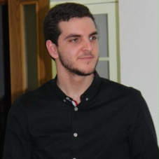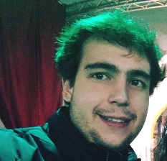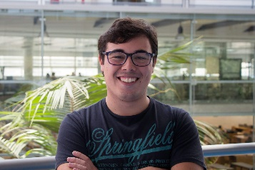

Bernardo Eichler

Diogo Martins

Diogo Santos



**Game Overview**

* Idea

The main focus will be on bringing the 80’s action movie camp with the cheesy one-liners and cliché dialogue, and at the same time, make a teen’s fantasy come true: to face several armed men in his school and winning against all odds, while playing hide and seek with the bad guys. For this it’s necessary a good character-driven story, mainly the dynamics between The Player and Huns Burger.

So, main plot goes along something like this: Huns Burger, a ruthless, globally-feared terrorist, motivated by monetary gains assaults the campus of an engineering university seeking the latest and unique prototype of a revolutionary paper transistor and sell it to the highest bidder. Unfortunately for Burger, The Player happens to have too many hours of shooters and action flicks and manages to escape the assailant’s grasp.

Now its up to The Player to stop Burger and his men from getting the prototype and escaping…

* Highlights
* Play on a certain suspiciously familiar-looking university campus
* Save your friends from the terrorists and be a national hero
* Re-live the 80’s action-flick memories with campy dialogue, dry wit and cheesy one-liners
* Choose your approach to a situation in a sandbox-style map
* Improve your character’s skills with leader points
* Explore your campus in-depth and find more about its secrets
* Genre

Perspective Top-Down Shooter with elements of Stealth and Strategy

* Software and Hardware

The game would be developed using Unreal Engine 4 and the target hardware currently are Windows and MacOS platforms with a possibility of porting to consoles and handheld devices (Android and iOS)

* Game World and Characters

PI Hard is set on a university campus based on a real campus, and therefore a number of characters based on well-known, iconic figures of that same campus will be present or cameoing.

Regarding the main characters:

* **The Player –** an unnamed engineering student who finds himself in dire straits during the take-over and is the only chance of stopping the perpetrators. When Burger talks to the character, he addresses him as “Player” because to him this must be a game.
* **Huns Burger –** a ruthless German thieve searching for the only prototype of paper transistor, stored in one of the campus’ many labs. Burger will do whatever it takes to get what he’s looking for. Based on the character brilliantly portrayed by Alan Rickman.



**Competition**

* Turnover

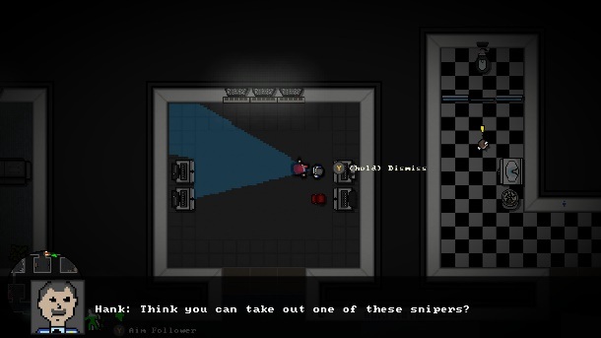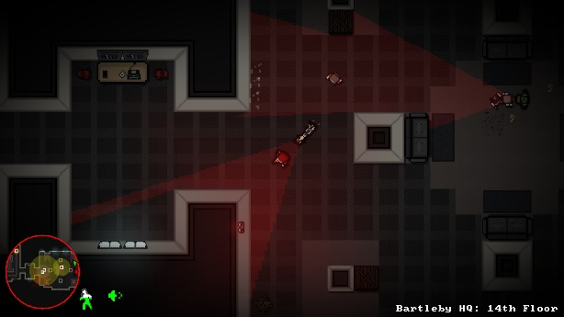

*In a dystopian future, a powerful corporation hires a private security firm to execute a violent takeover of a competitor's HQ. Caught in the middle, brave office worker Clea attempts a stealthy escape. - Steam*

* Agent RX

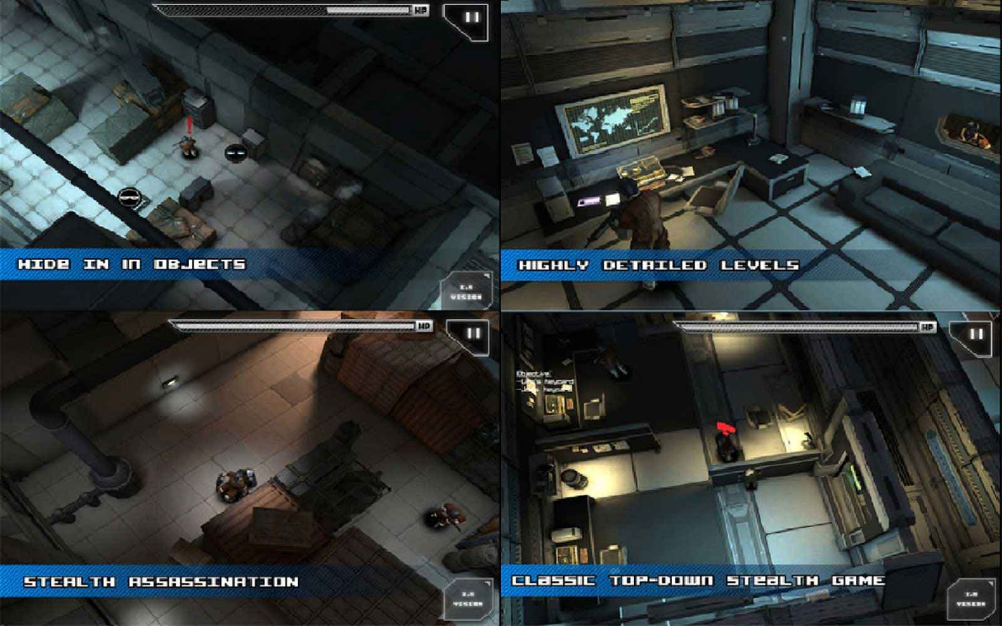

*A top down “tap-tical espionage shooter” (sic), an homage to the Metal Gear Solid series. Available to Android and iOS only.*



**Business Model**

* Marketing

Right now, the best marketing is through Youtubers, Twitch streaming and the online community as followers will see the game being played and get the game themselves.

Bundles would also be interesting to bring visibility to the game.

* Sales

The game would be sold retail only through online distributors like Steam, Origin in a one-time transaction as physical packaging would be too costly and wouldn’t bring as much visibility and sales comparing with online.

Downloadable Content may be developed on a later date although there’s no plans for it right now.

**Production Details**

* Current Status

There’s currently a very rough prototype of two levels, gameplay only, without cutscenes nor storytelling.

* Development Team

The development should consist in:

* + 1 Senior Programmer/Project Manager
  + 3 Main Programmers
  + 1 Art Designer
  + 1 Sound Designer
* Schedule

The whole game is expected to be finished sometime between the end of 2018 and the beginning of 2019, preferably before Christmas so we can gain some visibility and come out with strong sales during the holiday season.

This schedule is only for the PC and Mac release, mobile port should take no more than another year so that we can take into account compatibility issues and bugs.

* Budget

The expected budget should be between 200.000€ and 250.000€ for the PC and Mac release, mobile ports are not taken into account neither are DLCs should there be at all.